Lab Report – 3

Part A: Multiplexer

Moida Praneeth Jain (2022101093, Group 4, Table 16)

**Objective**

* To design, assemble and test a 4:1 Multiplexer using basic logic gates.
* Take inputs and select lines from Arduino.

**Electronic Components Required**

* Power Supply
* Breadboard
* LEDs
* Resistors
* Wires
* IC 7404 (Hex Inverter)
* IC 7411 (Triple 3-Input AND Gate)
* IC 7432 (Quad OR Gate)
* Arduino UNO

**The Reference Circuit**

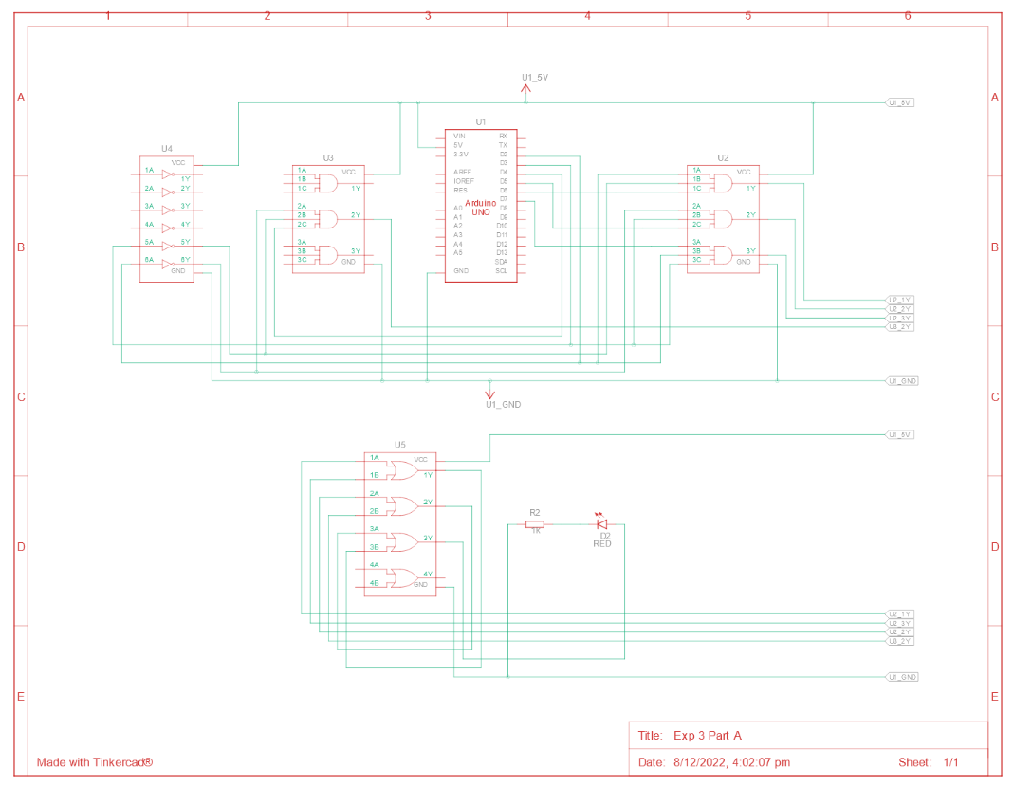

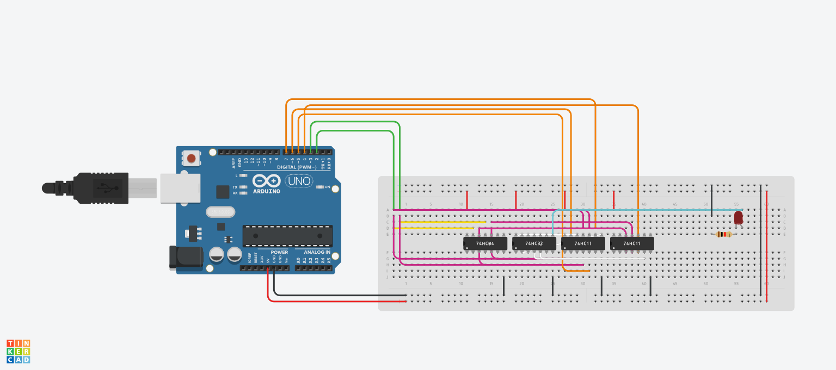

**Procedure**

* Connect VCC and GND from the Arduino to the breadboard.
* Connect the power and ground pins of each of the ICs to VCC and GND using red and black wires respectively.
* AND I3, S1, S1, then AND I2, S1, S0’, then AND I1, S1’, S0, then AND I0, S1’, S0’, finally OR all four of these outputs and connect the output to the LEDs anode.
* Connect the LEDs cathode to GND through a resistor.

**Observation**

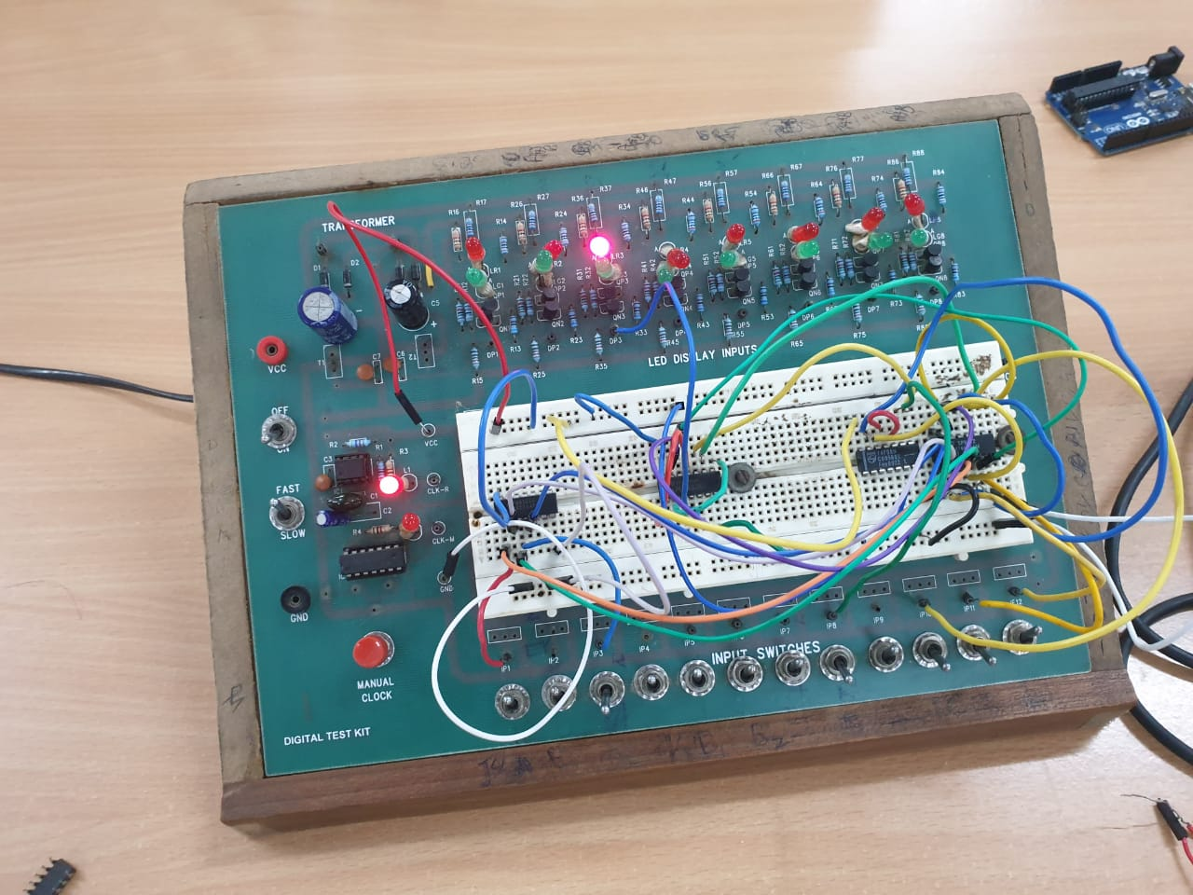

|  |  |  |
| --- | --- | --- |
| S1 | S0 | Y |
| 0 | 0 | I0 |
| 0 | 1 | I1 |
| 1 | 0 | I2 |
| 1 | 1 | I3 |

**Conclusion**

* For each combination of the select lines, one input line is being selected.
* The multiplexer is working as expected.

TinkerCAD simulation link:

<https://www.tinkercad.com/things/67zfnaa3WP1-exp-3-part-a/editel?sharecode=N5lO6MOA6-Bvoulp1yIW0YfMKbr6FFE8j7r0x10kEMA>

Part B: Demultiplexer

Moida Praneeth Jain (2022101093, Group 4, Table 16)

**Objective**

* To design, assemble and test a 1:4 Demultiplexer using basic logic gates.
* Take input and select lines from Arduino.

**Electronic Components Required**

* Power Supply
* Breadboard
* LEDs
* Resistors
* Wires
* IC 7404 (Hex Inverter)
* IC 7411 (Triple 3-Input AND Gate)
* Arduino UNO

**The Reference Circuit**

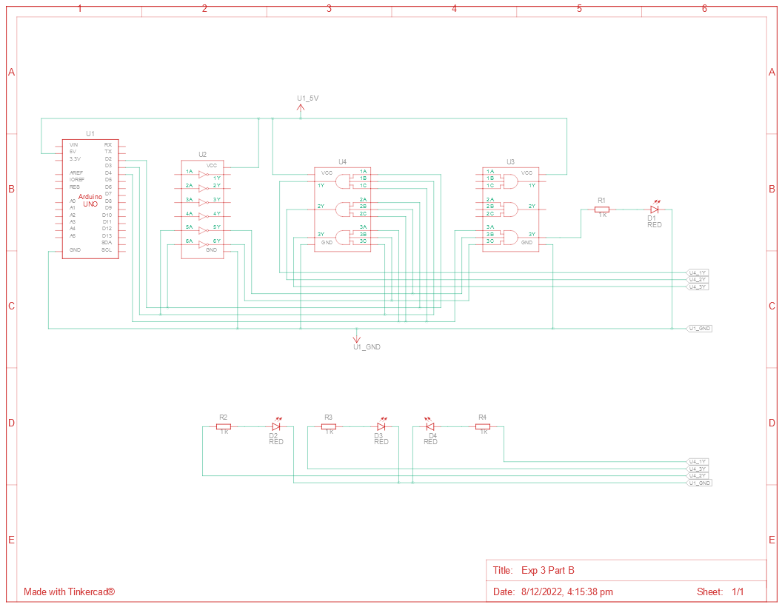

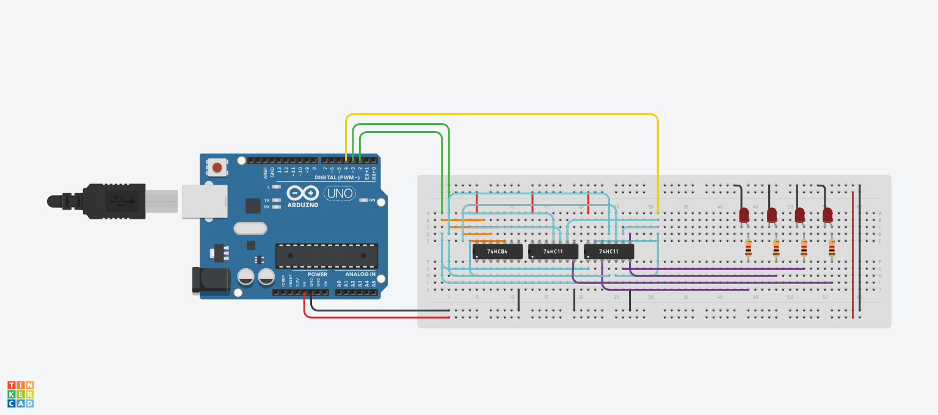

**Procedure**

* Connect VCC and GND from the Arduino to the breadboard.
* Connect the power and ground pins of each of the ICs to VCC and GND using red and black wires respectively.
* AND S1, S0 and I. Connect this to an LED’s anode. This will be output y3.
* AND S1, S0’ and I. Connect this to an LED’s anode. This will be output y2.
* AND S1’, S0 and I. Connect this to an LED’s anode. This will be output y1.
* AND S1’, S0’ and I. Connect this to an LED’s anode. This will be output y0.
* Connect the LEDs’ cathode to GND through a resistor.

**Observation**

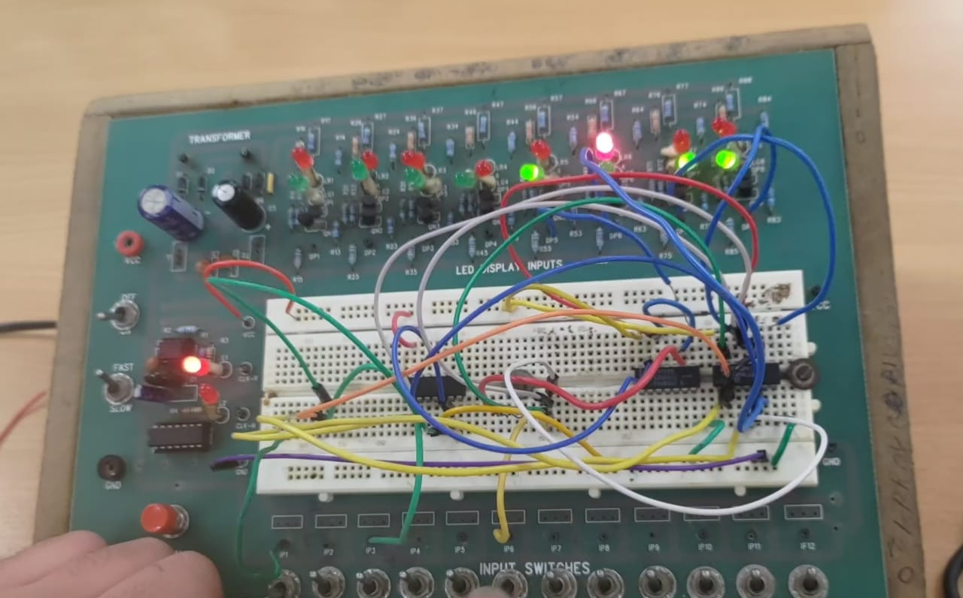

|  |  |  |
| --- | --- | --- |
| S1 | S0 | Output |
| 0 | 0 | Y0 |
| 0 | 1 | Y1 |
| 1 | 0 | Y2 |
| 1 | 1 | Y3 |

**Conclusion**

* For each combination of the select lines, a different output line is being selected.
* The demultiplexer is working as expected.

TinkerCAD simulation link:

<https://www.tinkercad.com/things/9sczqz8v9st-exp-3-part-b/editel?sharecode=mP_sxrzSKcZ0HAJWAIJOwRyQms9fZj5XasSOZFkGvrY>

Part C: MUX and DEMUX

Moida Praneeth Jain (2022101093, Group 4, Table 16)

**Objective**

* Assemble and test a 4:1 multiplexer and 1:4 demultiplexer by viewing the corresponding output in LEDs.
* Take inputs and select lines from Arduino.

**Electronic Components Required**

* Power Supply
* Breadboard
* LEDs
* Resistors
* Wires
* IC 7404 (Hex Inverter)
* IC 7432 (Quad OR Gate)
* IC 7411 (Triple 3-Input AND Gate)
* Arduino UNO

**The Reference Circuit**

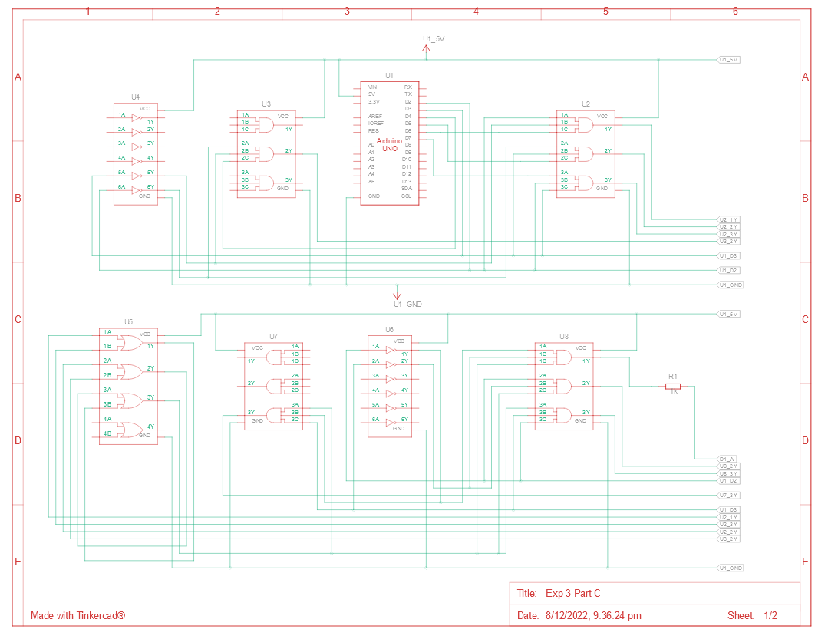 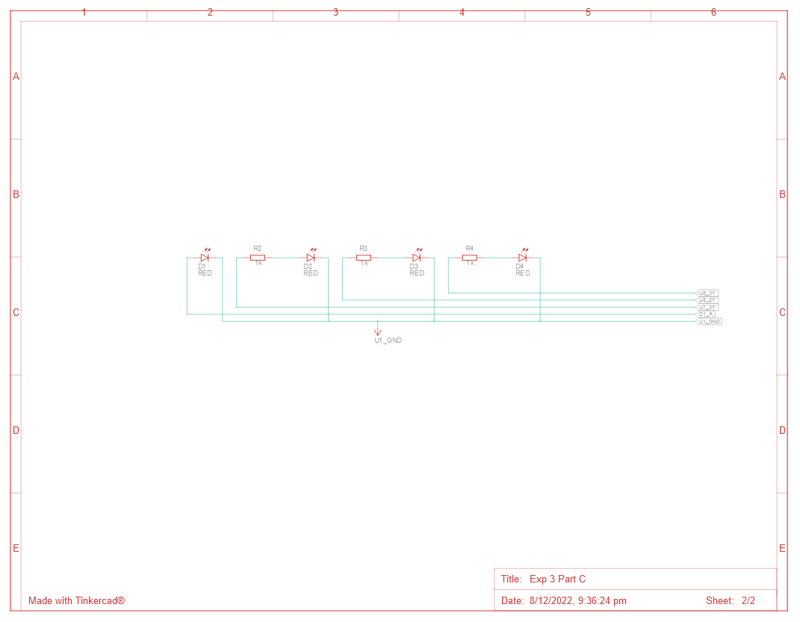

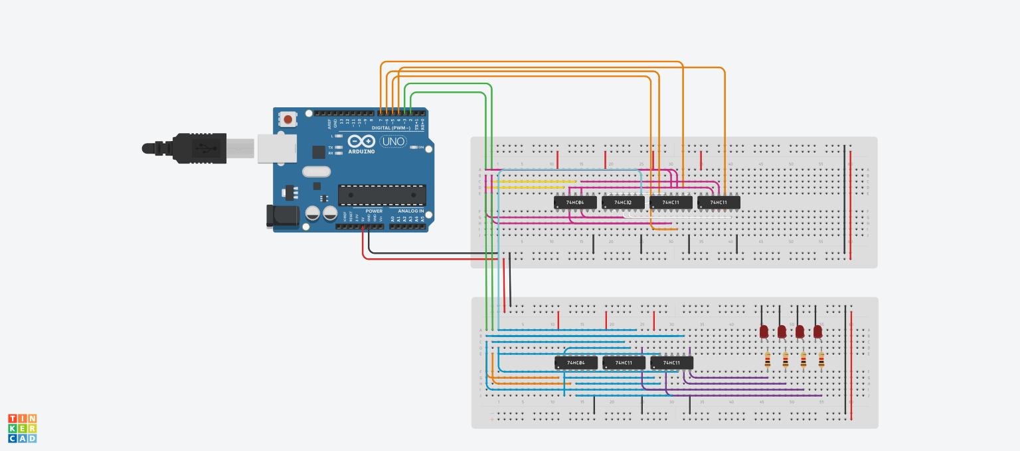

**Procedure**

* Connect VCC and GND from the Arduino to the breadboard.
* Connect the power and ground pins of each of the ICs to VCC and GND using red and black wires respectively.
* AND I3, S1, S1, then AND I2, S1, S0’, then AND I1, S1’, S0, then AND I0, S1’, S0’, finally OR all four of these outputs and connect the output to the breadboard. Let this output be I.
* AND S1, S0 and I, AND S1, S0’ and I, AND S1’, S0 and I, AND S1’, S0’ and I, connect the output of each of these AND operations to an LED’s anode.
* Connect the LEDs’ cathode to GND through a resistor.

**Observation**

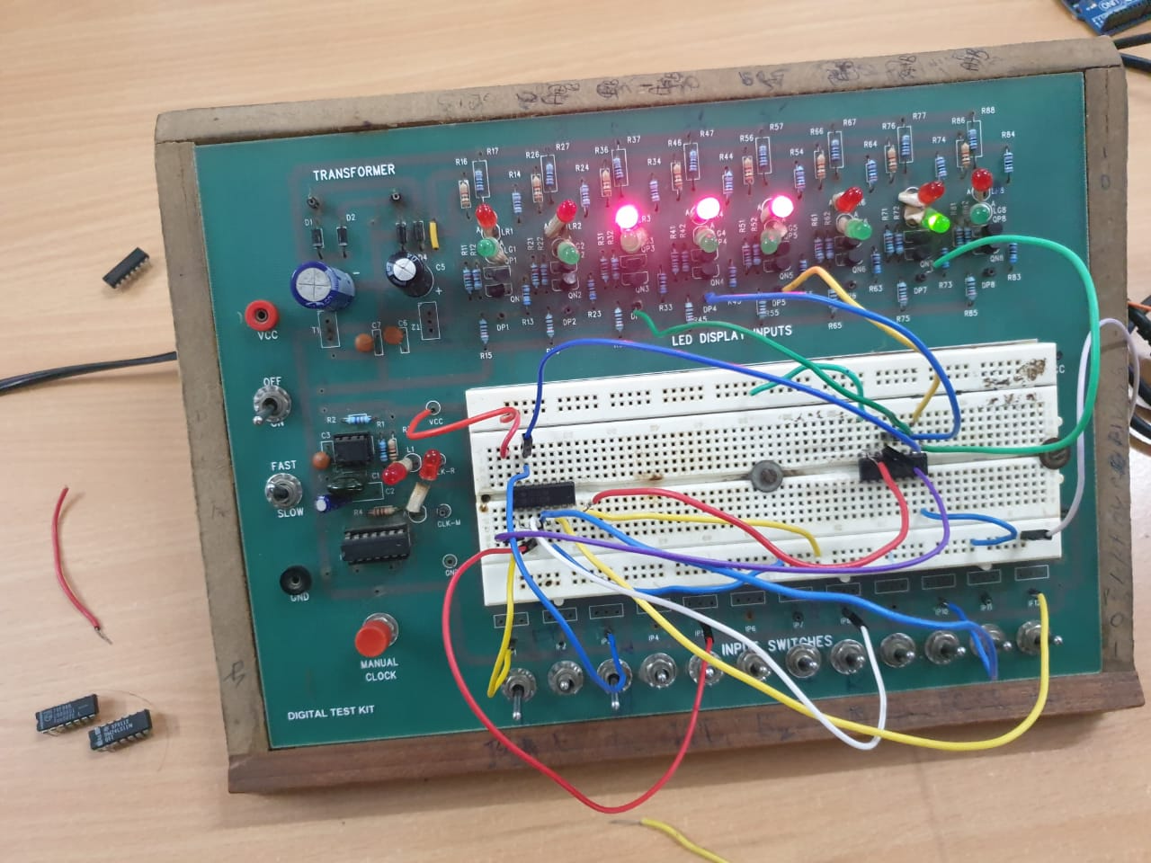

* For each combination of the select lines, one of the four inputs will have its corresponding LED turn on, while the other three inputs will not do anything.

**Conclusion**

* The multiplexer and demultiplexer are working as expected.

TinkerCAD simulation link:

<https://www.tinkercad.com/things/1AC1B5uDzrE-exp-3-part-c/editel?sharecode=SPg8v5hlKvjYWaokCkQS4cg6l9rsUio5XbiiEzIsm6o>

